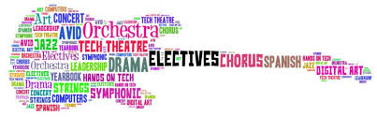Supply List

**Arts Students need to bring the following items to class each day:**

Pencils

Erasers

Sketchbook

**Music Students need to bring the following items to class each day:**

Pencils

Chromebook

**Technology Students need to bring the following items to class each day:**

Pencil

Chromebook

**Physical Education Students need to bring the following items to class each day:**

Sneakers

Chromebook